Java
jdk=java development kit
java is object oriented language

Classes
A class is a custom type. An example of a class would be String, or GraphicsContext. Class names usually start with a capital letter. You can create a class by writing ‘class’ in front of the name and declaring its fields and methods.
A field is a variable that lives inside a class.
A method is a function that you can run to interact with the class.
F() - function call
abcOBJ.f() - method call on the reference named abcOBJ
Example:
class Cat{

// This field is called isFat, this variable only holds true or false. It // tells you whether or not your cat fat or skinny.
boolean isFat;
boolean isMean;
boolean isMixed;
String name;

// This method feeds your cat. If you feed the cat 1,000 calories or more // while it is skinny, it will become fat.
void feed(int calories) {
if(calories=1000) {
isFat=true;
}

void print() {
printf("\n is fat="+isFat);
printf("\n is mean="+isMean);
printf("\n is mixed="+isMixed);
printf("\n name ="+name);
printf("\n is female="+isfemale);
}
}
}
Now, you have created a class with a method. You have created a class cat which has the properties is skinny, mean, mixed, and their name is Snowball. You can print them by going to jshell, and typing /open (file path). Create a new cat by typing:
jshell> Cat jiji= new Cat();
jiji ==> Cat@18be83e4
jshell> jiji.print();

is fat=false
is mean=true
is mixed=false
name =Default
is female=true

To feed them type:
jshell> jiji.feed(4540);
jshell> jiji.print();

is fat=true
is mean=true
is mixed=false
name =Default
is female=true

If you feed them more than 1,000 calories, they should become fat. You can check this by printing them again.
You can change fields directly using dot operations.
Example:
jshell> jiji.isFat=false;
jshell> jiji.print();

is fat=false
is mean=true
is mixed=false
name =Default
is female=true

jshell> jiji.name="jiji";
$62 ==> "jiji"

jshell> jiji.print();

is fat=false
is mean=true
is mixed=false
name =jiji
is female=true

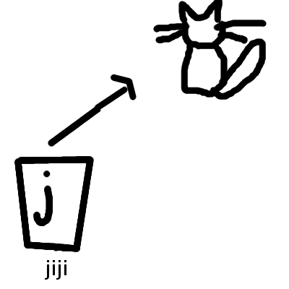

Java Objects
A java object has a unique id which is generated by java when the object is created.
Example:
jshell> new Cat();
$53 ==> Cat@4b9e13df

In this example, the id is Cat@4b9e13df.

Variables
There are two kinds of variables. One of which is normal, and the other one is a reference variable.
Reference always have class type and non-reference variables always have non-reference type.\

Websites
Websites are stored on a web server and they are made of web pages. Every web page has an address (also know as a link or URL)
Example:
youtube.com-website
→ youtube.com/v1-web page
→ youtube.com/v2-web page
→ youtube.com/v3-web page

Web pages are made in HTML. HTML is a HyperText Markup Language

Markup Languages
-HTML
-MarkDown

Git Commands
git log
Shows all commits
git show (commit id)
Diffs in the commit

Alpha Channel
First there was a jpeg file but you couldn’t make the image transparent so they made a png.

Alpha is a number that defines the transparency of pixels. Alpha channel is present only in png files.
100- not transparent
50- foggy
0- transparent

Variable Life Cycle
Variables live in the arguments of a function and in the body.
void example(int a) {
int x=123; //1
printf(x);
} //2

The variable is born when its created (line 1). You can use the variable after its created, but before the function ends. The variable dies once the function is completed (line 2).

Global Variables
A global variable is created once a program starts. It dies once the program is completed. Global variables are declared in the program’s code, but outside of all functions.

Local Variables
Unlike global variables, local variables live only inside a function.
int global=16;
void function(){
int local=5;
global=8;
}

How to use Mod to chop numbers
The operation mod, can not only give you the remainder when dividing a number, but can also chop off the last digit in a number when using mod 10.
Example:
25%10=5

ROM
ROM stands for Read Only Memory. Unlike RAM(Random Access Memory), ROM cannot be changed by the user.

Bootstrapper
A bootstrapper is a tiny chunk of code that lives in ROM preinstalled on the motherboard of a computer. It lives in ROM so that nobody can change it or break it accidentally. If it didn’t live in ROM and you accidentally change it then it might stop working and nothing will run. A bootstrapper helps power on the Operation System.

The bootstrapper process
Once you press he power button on a computer/phone/etc,. bootstrapper is launched. Then it sets off a chain of events to load OS (Operation System) and goes back to sleep.

OS
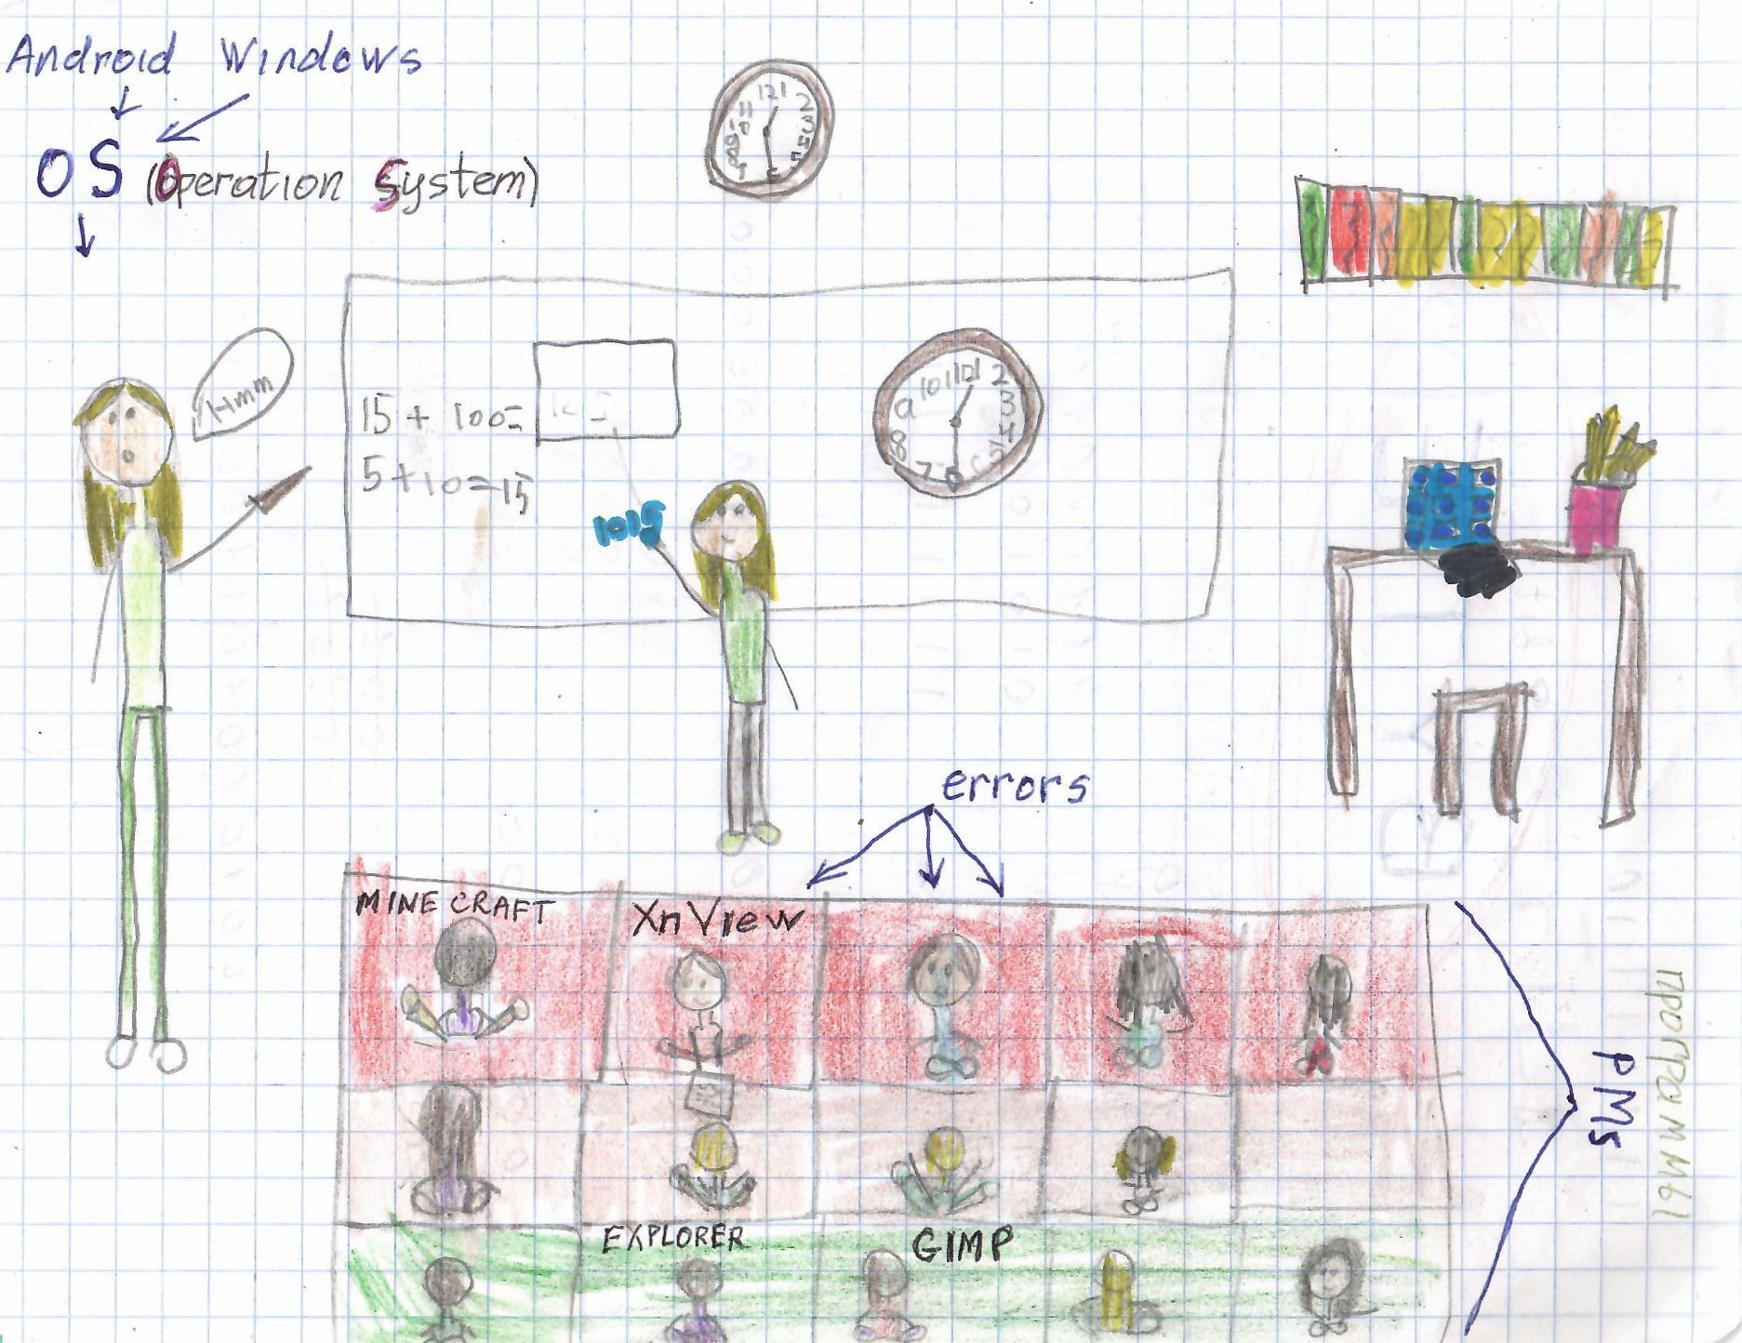
The OS lives in RAM (Random Access Memory)

Lbgdx
Lbgdx doesn’t actually draw. It calls the draw function which draws 32 fps. The user decides what to draw.

ShapeRenderer
Helps you draw shapes like lines, points, circles, etc

Sprite batch
A sprite batch helps you project your textures on your screen in lbgdx. A batch helps you project not one by one but all textures at once. Sprite batch helps you send information to GPU faster, which makes GPU display it faster. For example if you have five textures, without sprite batch you would have to send them one by one. You would send one texture, which could take 1 second, and then the second one and so on. With Sprite batch, you would send them all in one batch. So instead of taking 5 seconds to send each individual texture, you would take 1 second to one batch with all 5 textures. To make a sprite batch, you have to write this to import sprite batch:
import com.badlogic.gdx.graphics.g2d.SpriteBatch;

Then, to create sprite batch type this:
SpriteBatch [batch name] = new SpriteBatch();
[batch name].begin();
[batch name].draw([name of texture1],x,y);
[batch name].draw([name of texture2],x,y);
// ...
[batch name].draw([name of textureN],x,y);
[batch name].end();

Constructors
You define a constructor by defining a method with the name of your class in the body of your class. This method should not return anything because it will be returning the class. You run the constructor by saying new and then calling the constructor. The purpose of a constructor is to initialize an object of its type.
Defining the constructor:
Fly(int y) {
ky=y;
printf("hello from defult fly constructor.");
}

Running the constructor:
new Fly(330);

Default Constructors
Constructors that don’t have any arguments are called default constructors, java always creates them. If you want to change a default constructor:
Fly() {
printf("hello from defalt fly constructor.");
}
Example of running default constructor:
Fly fly= new Fly();

Initialize….
Initialize is the very first process in a workflow. If initialize doesn’t work, the whole process with crash. For example if you want to eat yogurt, the initialize would be to make sure that you even have yogurt or something to eat it with. If you don’t have yogurt then the whole idea or process of eating yogurt would crash.

Assignment

left side = right side
It is an operation of assigning whatever is on the right side to whatever is on the left side.

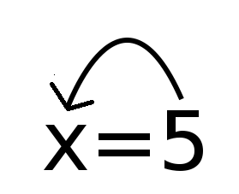
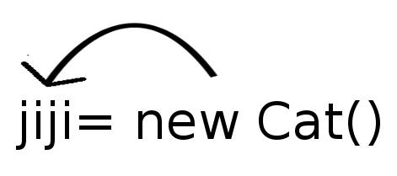
Step 1: make a new Cat object
step 2: assign reference to new Cat object to a variable or array element, etc

Abstraction
Abstraction is the different ways of modeling or interpreting something.
Example
graphical model:

java model:
class LL {
Node head;
}

class Node {
String value__field;
Node next__field;
}

It is important that both models should represent one to one. Both are models of linked lists with nodes and links.
Graphical model | Java model
arrow | next__field reference
rectangle box | class Node
text | value__field

software development workflow
1) idea
2) analyze the idea
- do you have time?
- Does it worse it (is it worth it)?
3) development cycle: make small change, run the program, analyze its behavior, and repeat. Different techniques to help analyze:
- debug: add logging, state table
Example:
printf("fly with id:"+id+" has kx "+kx+" and ky "+ky+"\n");

Data structures

Array
To create an array, you must specify its size. All arrays have fixed length. That's why they are called fixed size arrays.
jshell> a=new int[];
| Error:
| array dimension missing
| a=new int[];
| ^-------^

Linked Lists
Easily expandable chains of data (unlimited number of nodes). You have to scan to the correct location to read/modify a piece of data in that node. A node is something that holds values. Linked lists proprieties: size, head nodes, tail nodes,
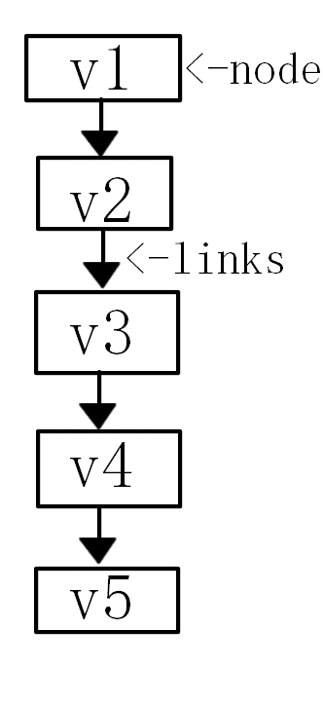

Java operators

New:
new Node();
$5 ==> Node@4ccabbaa
It will:
Step 1. Creates an empty object with the specified type and assigns it a unique id.
Step 2. Initializes this object by calling default constructor.
Step 3. Returns the reference to the object

new Node("drpepper");

It will:
Step 1. Creates an empty object with the specified type and assigns it a unique id.
Step 2. Initializes this object by calling a non default constructor.
Step 3. Returns the reference to the object

Graphs
The traveling salesman in a problem in which a traveling salesman needs to get to multiple houses/stores traveling the shortest amount of distance possible.

Comparing Refrences
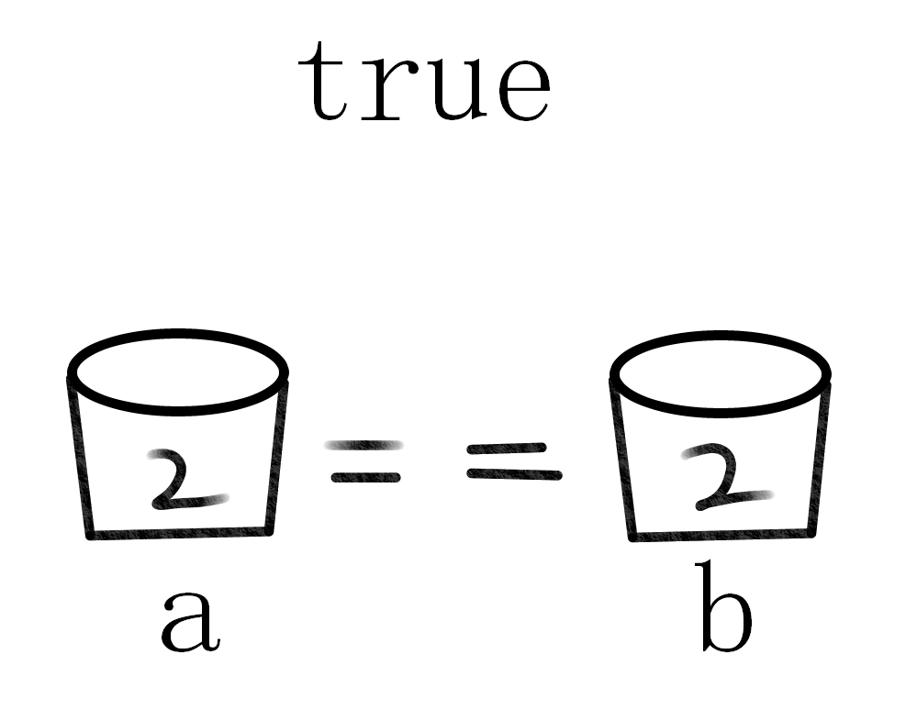
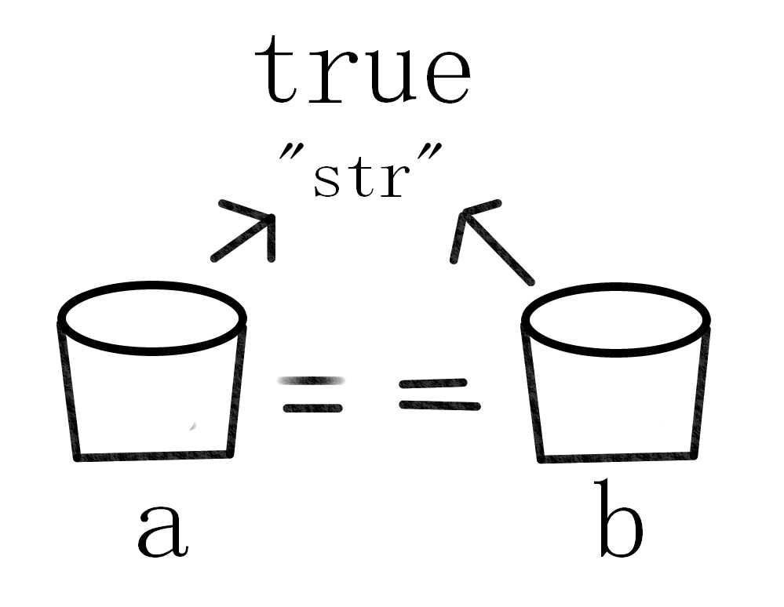
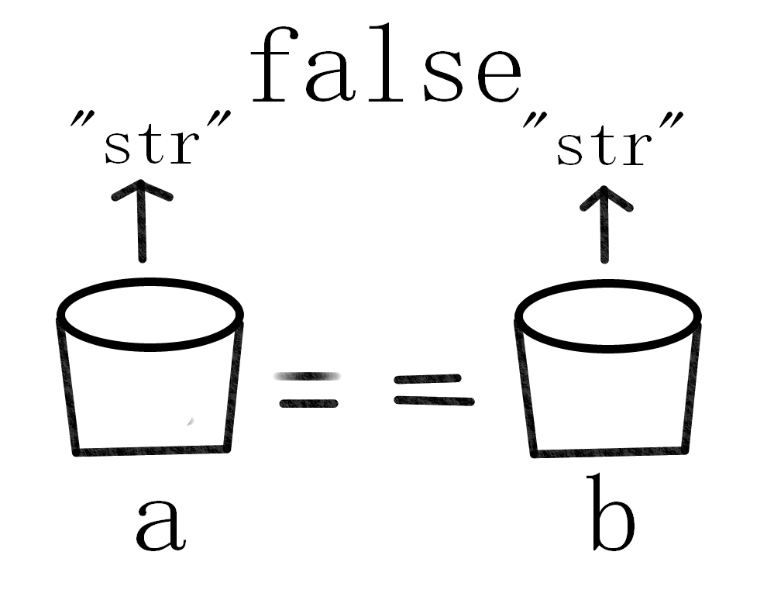
== compares the references and not the objects which they point to
If you want to compare their ojects, then use
Objects.equals(a,b).

NPE
NPE stands for null pointer exception and you can get it if you make a variable and use a method on it while the variable is null.
Example:
String a;
a ==> null

a.chars();

Exception java.lang.NullPointerException: Cannot invoke "String.chars()" because "REPL.$JShell$11.a" is null
at (#2:1)

After you put something into the variable the npe goes away.
Example:
a="hello";
a ==> "hello"

a.chars();
$4 ==> java.util.stream.IntPipeline$Head@4cc77c2e

Motherboard
The motherboard is the big thing inside of your computer which you plug everything into for example your headphones, mouse, display, and much more. It is very important because if you didn’t have it your computer wouldn't work.

Network Adapter
The network adapters gives you network one example of a network adapter is the WiFi network adapter. The WiFi waves travel through the air into your computer into the WiFi network adapter. There are other examples of network adapters such as Ethernet and Bluetooth. Each network adapter has its own unique MAC address and all of them are plugged into the motherboard.

